

**CS-114 - Fundamental of Programing**

**Lab Manual # 8**

**Lab Task**

Submitted To: Engr Muhammad Affan

Submitted By: Shahzaib Murtaza (466034)

Section: B

Task # 1

#include <iostream>

#include <bits/stdc++.h>

using namespace std;

int main()

{

double s = 0;

int x[5] = {23, 57, 45, 65, 5};

for (int i = 0; i < 5; ++i){

s = s + x[i];

}

cout << s / 5;

return 0;

}

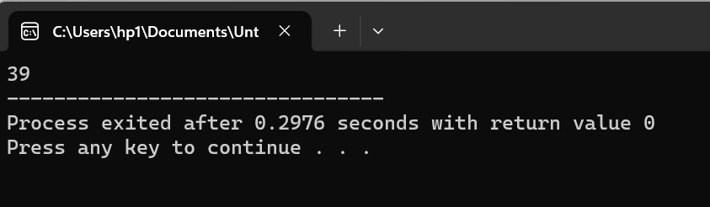

Task # 2

#include <iostream>

#include <bits/stdc++.h>

using namespace std;

int main()

{

int temp;

int x[5] = {87, 54, 23, 9, 13};

for (int i = 1; i <= 5; ++i){

for (int j = 0; j < 4; ++j){

if (x[j] > x[j+1]){

temp = x[j];

x[j] = x[j + 1];

x[j + 1] = temp;

}

}

}

for (int k; k <5 ; ++k){

cout << x[k] << "\t";

}

return 0;

}

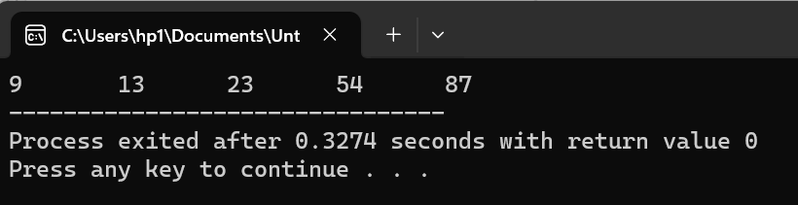

Task # 3

#include <iostream>

#include <bits/stdc++.h>

using namespace std;

int main(){

int minimum;

int x[5] = {11, 54, 9, 23, 62};

for (int k=0; k <5 ; ++k){

cout << x[k] << "\t";

}

cout << endl;

for (int i = 0; i<5; ++i){

minimum = x[i];

for (int j = i; j < 4; ++j){

if (minimum > x[j]){

minimum = x[j];

x[j] = x[i];

x[i] = minimum;

}

}

}

for (int k; k <5 ; ++k){

cout << x[k] << "\t";

}

return 0;

}

